Introduction:

A sequence container is used for encapsulation of task in package or a sequence container maybe considered as a **sub-control flow** of a package. Sequence container really helps full when we are using multiple operations to perform synchronously or asynchronously (like multi-threading).

Sequence container can be used for:

* Managing properties of multiple tasks together by editing properties of the container.
* Groping many tasks so that we can manage expanding and collapsing of them together.
* To set a transaction attribute to a sequence container to define transaction rules for a subset of package control flow.

Aim:

By using sequence container we would load data from excel file to SQL database.

Which will be having same database name objects and same task name.

Both of them would run synchronously.

Tools required:

* SSIS tool
* SSMS tool.
* Excel file.

Step to perform this task:

**Step 1:**

Make a package in SSIS and create data tables in SSMS.

Drag and drop two sequence container from   SSIS tool > Container > sequence container.

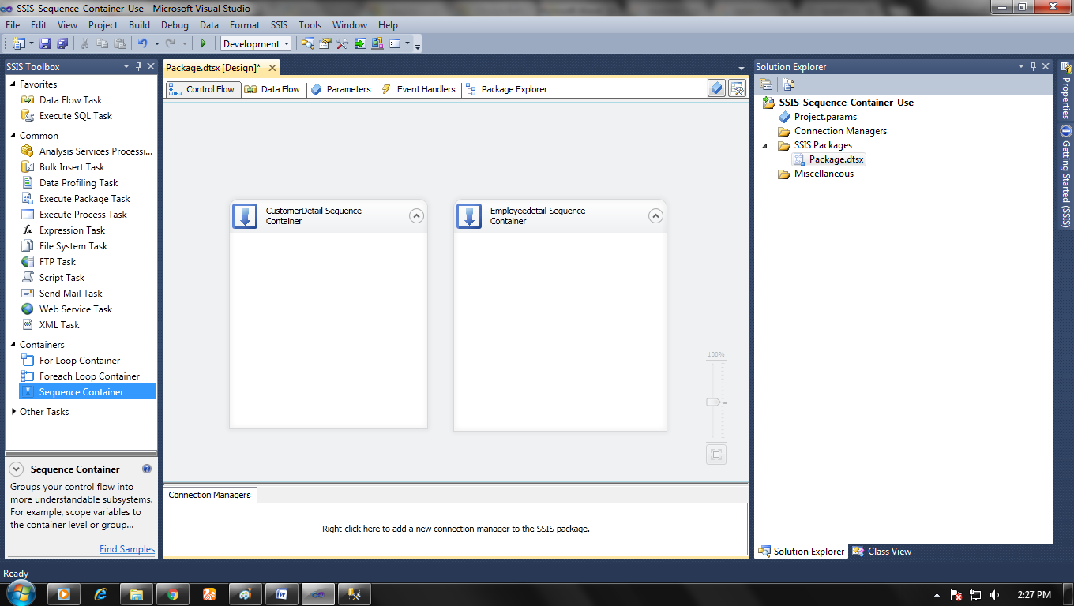

**Step 2:**

Now set up data flow for each sequence separately.

Double click on data flow in sequence and a window will pop up, set source and destination task for that data flow.

Repeat for other sequence container flow also.

**Note: don’t forget to add data conversion, to convert data in the appropriate format and do mapping properly in data destination editor.**

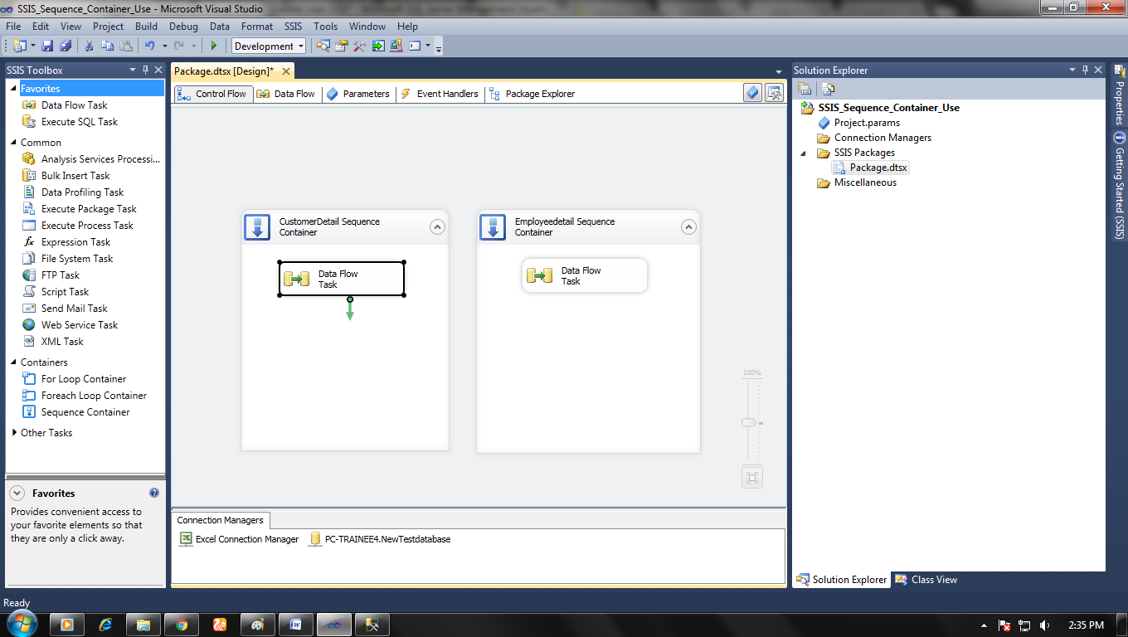

Data flow window

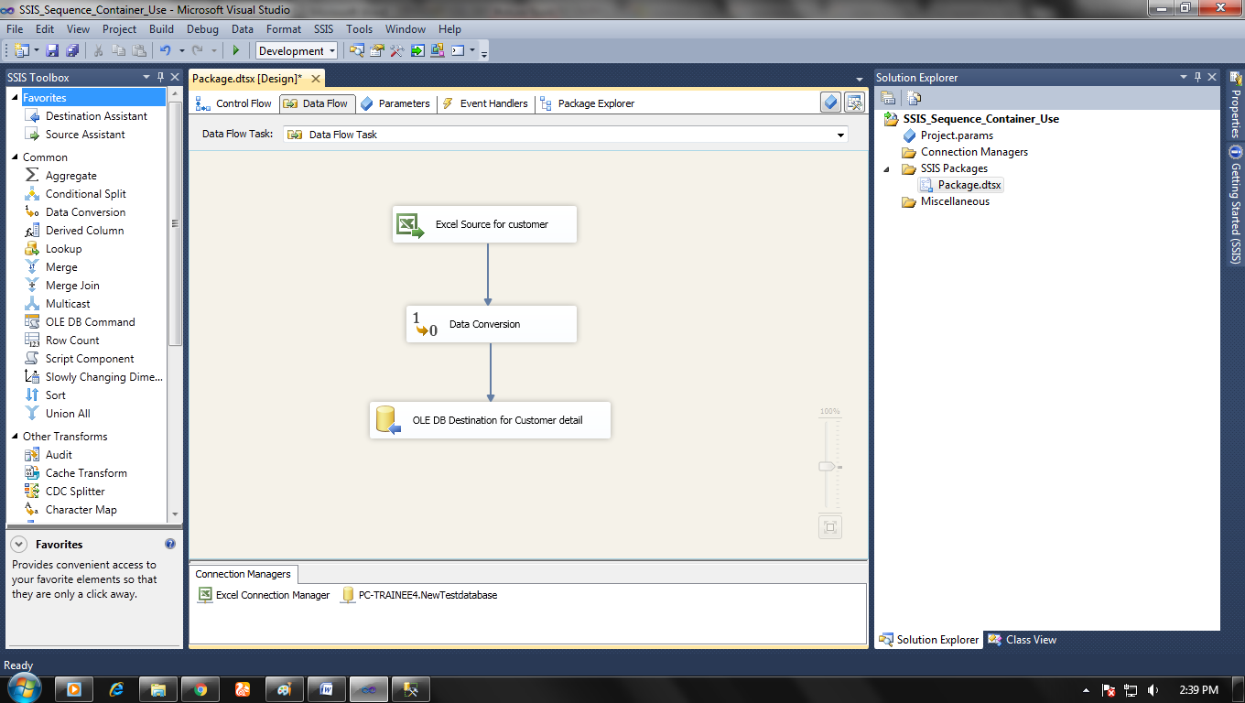

Step: 4:  ADD a SQL execute the task in sequence also if you want to truncate table before loading new data.

 When everything is done then start our package by clicking F5 or click run debugging.

* Result in SSIS

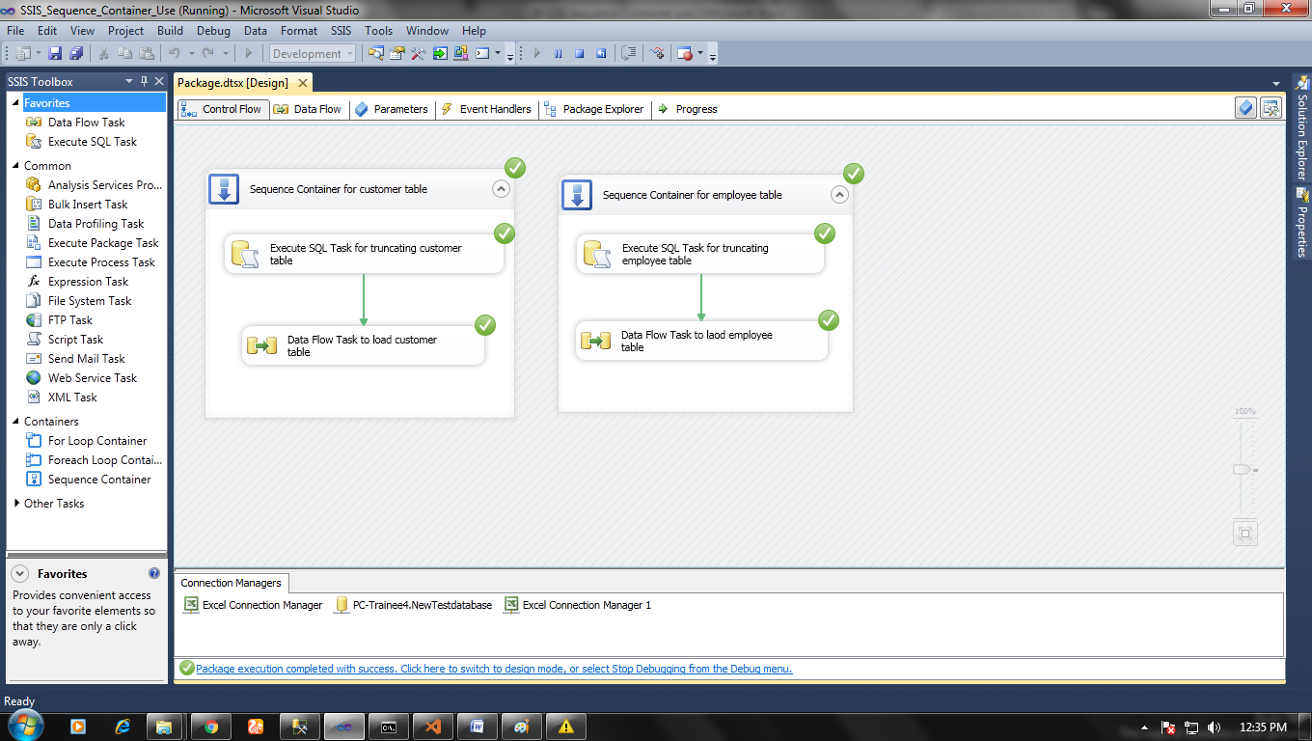

Any sequence also can have multiple sequences inside of it, and multiple sequences can be joined with precedence constraint.

* Result in Database

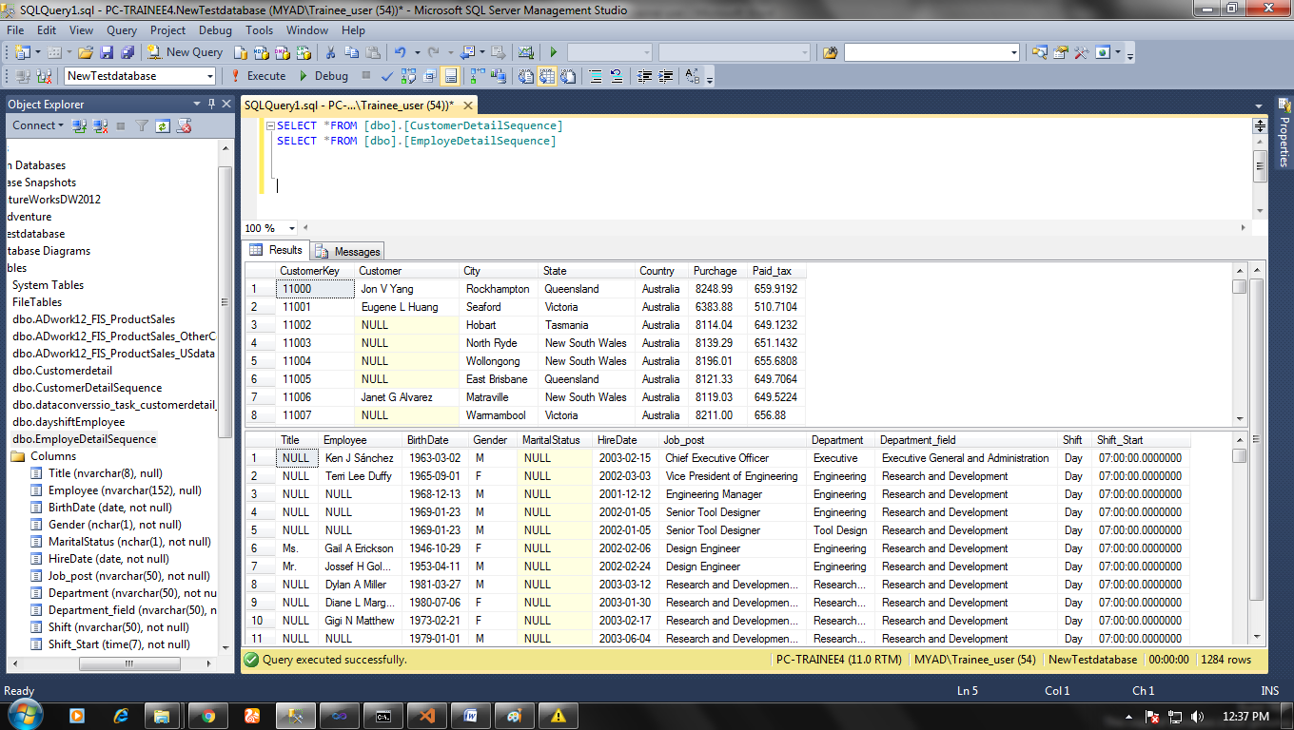

**Note:** if you are also converting data file from excel to database table then it would be better to set Run64bitruntime to False because it may throw an error.

**Package name > properties > Configuration properties > debugging> Run64bitruntime= False**